Project title: Environment Terrain Risk Analyser

Problem statement: Off road and desert environments pose major challenges for infrastructure planning and construction due to:
- Uneven terrain
- Vegetation density
- Surface instability
- Structural bottlenecks
Manual assessment is slow, subjective and expensive and comparative scaling in itself for different terrains for some specific projects in itself further complicates the entire procedure of land acquirement as the data isn’t quantified.
This project provides an automated visual analysis engine that identifies the environmental bottlenecks from the imagery used in the data via using the semantic segmentation.
To combat the said problem we quantify the terrain bottlenecks in a detailed analysis which hence provides us with parameters that can be used for comprehensive comparative analysis for the sake of reduced friction when building infrastructure in adversarial terrains.

Solution Overview:
We used a pretrained Deeplabv3(ResNet-50 backbone) semantic segmentation model to:
- Segment the terrain into meaningful classes
- Analyze structural obstacles(rocks, bushes, logs, ground clutter, etc.)
- Rank Environmental bottlenecks based on construction difficulty
- Output an interpretable risk summary for each image batch
This enables fast, scalable feasibility analysis for:
- Off-road construction
- Off-road vehicle planning
- Aid in Off-road vehicle design testing via simulation
- Infrastructure placement
- Environmental assessment

Features:
- Folder-level batch image processing
- Semantic segmentation using DeepLabv3
- Hierarchical risk scoring
- Lightweight inference pipeline
- Modular codebase (geometry, model, utils)
- Works with arbitrary datasets
- No hardcoded paths
- Deployment ready

Tech Stack:
- Python
- Pytorch
- Torchvision
- OpenCV
- Pretrained DeepLabV3
- GitHub (for deployment and evaluation)

How it Works (High level):
- Input: folder of environment images
- Model performs semantic segmentation
- Classes are mapped to infrastructure risk priorities
- Output: environmental feasibility analysis per image batch

Assumptions:
- Uses pretrained weights
- Dataset images represent off-road/desert terrain
- Risk hierarchy is domain-informed (can be tuned)
- Optimized for fast prototyping, not final production

Future Work:
- Fine tuning on domain specific datasets
- Real time drone feed integration
- Terrain slope + depth estimation
- Infrastructure cost simulation
- GIS system integration
- Deployment as a web tool/API

Input (image batch iteration 1):
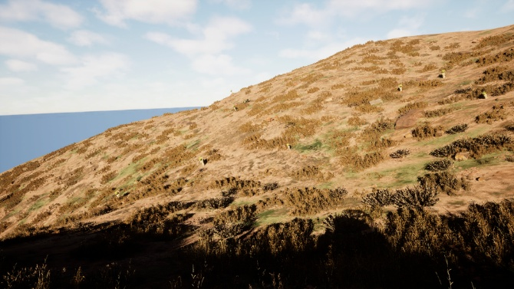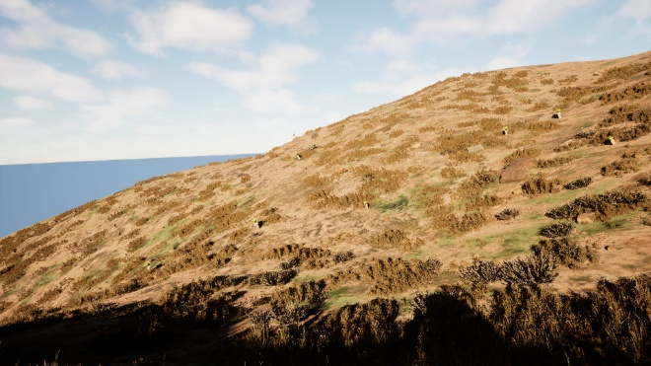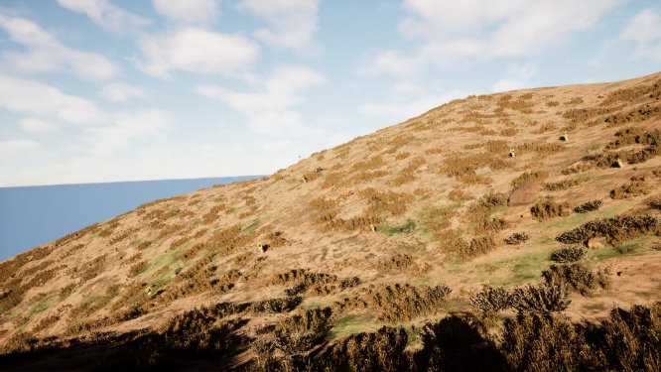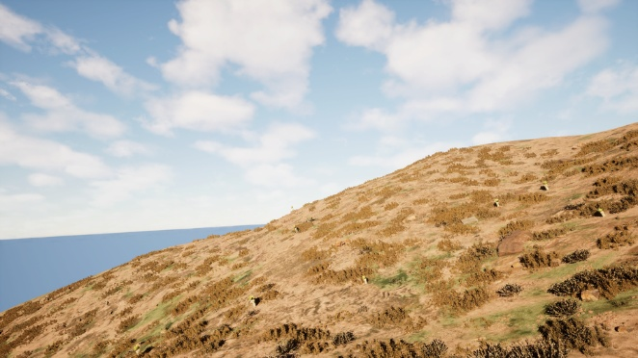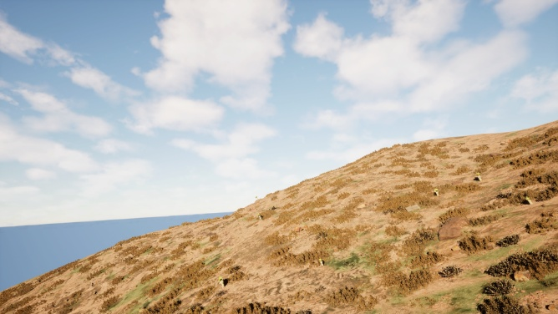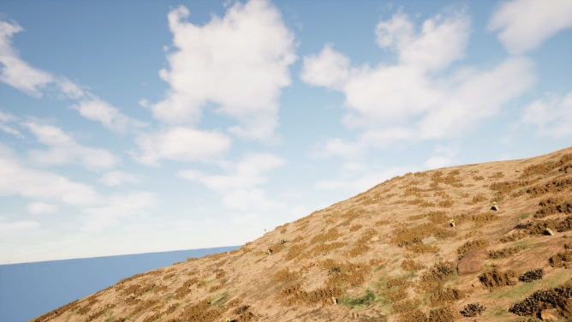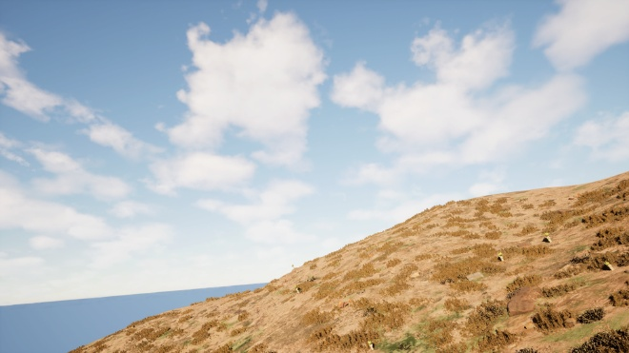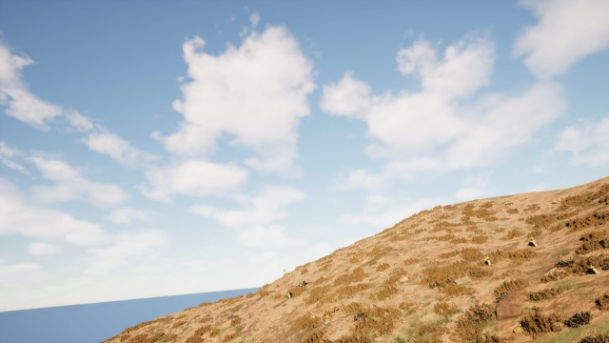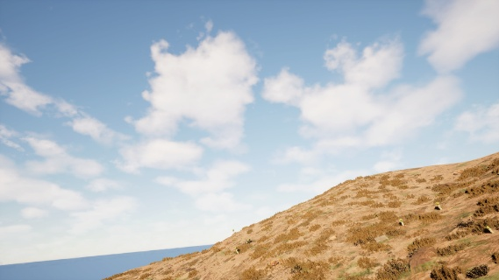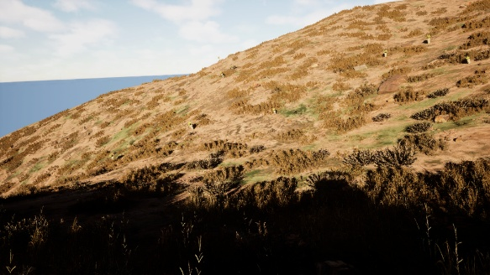

Output (image batch iteration 1)
